The John & Annie Glenn Museum

Presents
a Study Guide
for

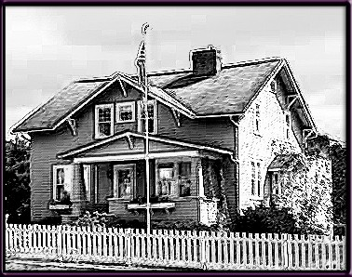

Written and Compiled by: Sally Brixner, Carol Campbell, Joanna Duncan, Joan Hoon, Charlotte Simpson, and Betsy Taylor
Edited and Designed by: Catherine Borkoski

World War II Study Guide Table of Contents
This guide may be used by teachers and visitors at all age levels. However, we have organized it by specific grades and topics. Feel free to adapt for different age levels.
- Kindergarten - 2nd Grade

Language Arts
Blue Star Victory Flag 2

Mathematics
Price Comparisons: WWII and Today 3

Social Studies
Children’s Chores 4

Science
Victory Gardens 5

- 3rd and 4th Grade
Language Arts
Toys from WWII 6
Mathematics
Rationing 7
Social Studies
War Bonds 8
Science
Morse Code 9

- 5th Grade and Above

Language Arts
Oral Histories: Veterans 10
Oral Histories: On the homefront 11
Word Search 12

Mathematics
Rationing 13

Social Studies
Important People 14
Time Lines 15-16

Science
Recycling- Pie 17
Compost - Compost Pile 18
Answer Key is located on page 19

The John and Annie Glenn Historic Site

World War II Study Guide

This guide was created to give information concerning World War II to allow visitors to the historic site to better understand the living history presentation. The information is divided into 4 categories:
Language Arts, Mathematics, Social Studies, and Science

There is information with some possible activities at all levels for your use.
Learning Objectives:
  - Identify some of the everyday experiences/sacrifices of people during World War II.
  - Compare World War II conditions to current economic and social conditions.
  - Develop skills of comparison using mathematics, science and social studies along with reading and writing skills.
  - Discuss the roles of family members in maintaining their lives within the community during World War II.
  - Analyze the historic background of this time period in America.
  - Synthesize the information in this guide to write a short story about a small town family coping with World War II on the homefront.

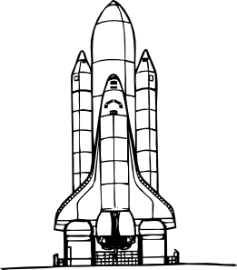

Grades K-2 The Great Depression – Language Arts
The Blue Star Flag

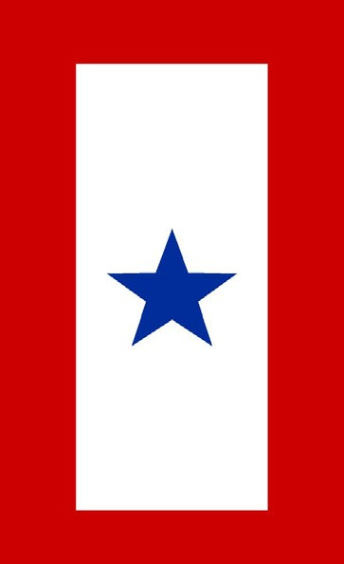

Look at the flag in the window. It is red, white, and blue. There is a large blue star in the center of the flag. That star tells everyone who sees it that there is someone from that home who is bravely fighting for our country.
In the Glenn home, the flag reminds us that John Glenn is away from home fighting for our country. We are very proud of John Glenn.
Help color in the flag that is in the window at the Glenn house.

Grades K-2. World War II - Math

1944 Mathematics

Bread $.10 a loaf
Milk $.15 a quart
Eggs $.18 a dozen
Hamburger $.12 a pound Campell’s Soup $.09 a can Crackers $.10 a box

During World War II the cost of many common items were significantly less than it is today. These problems will take you back to 1944.

    - Your mother sent you to the grocery store for a quart of milk and two loaves of bread. How much will you owe? If your mother gives you a dollar, how much change will you get?
The milk comes in a glass bottle, so be careful carrying it home. If you get your milk from a local farmer, it will not be pasteurized or homogenized. What do these words mean? Do a search to find out: who was Louis Pasteur?
2. Even children could raise money to help buy things used by soldiers to win the war. Children bought 10 cent saving stamps that they pasted in albums. When an album was filled, it was exchanged for a war time savings bond.

      - It takes 8 stamps to fill one page. Stamps cost 10 cents. How much money does it cost to fill one page?
      - How much money to fill four pages?
3. Your parents, your sister and you are going to the movies to see “Since You Went Away”, the story of women on the homefront coping while their sons, brothers and husbands are overseas serving in World War II. Adult tickets cost $.15 each and children’s tickets are $.10.
      - How much will your dad pay for the tickets?
      - If he gives the ticket seller a $1.00 bill, how much will he get back?
      - If popcorn costs $.05 a box, how much will he pay for a box for each of you?
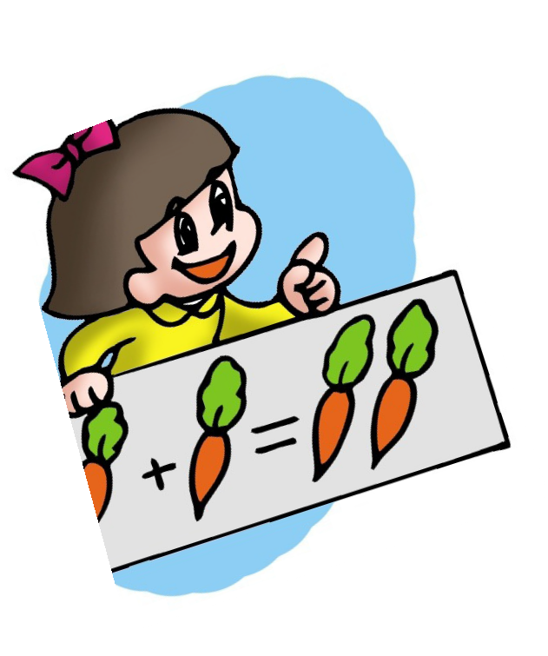
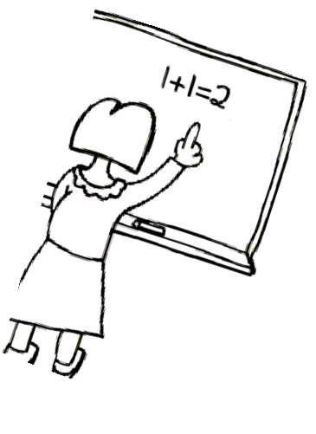
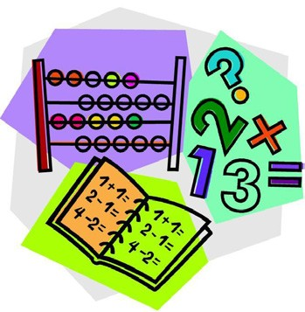
3

Grades K-2 World War II – Social Studies
Chores for Children during
World War II

When fathers were away during the war, mothers were working very hard to keep everything in the house running smoothly. They had a lot of help from the children in the family doing all sorts of things. Each child had some jobs, or chores, to do that would help the household out. This was very important.
Dusting Gardening
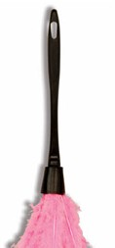
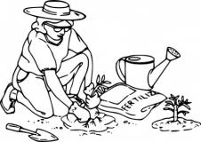
Folding Laundry Making Beds
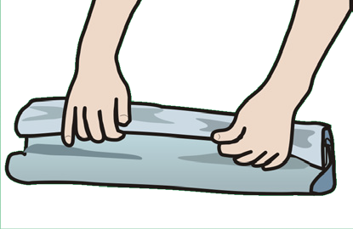
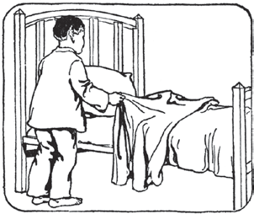
Setting the Table Childcare
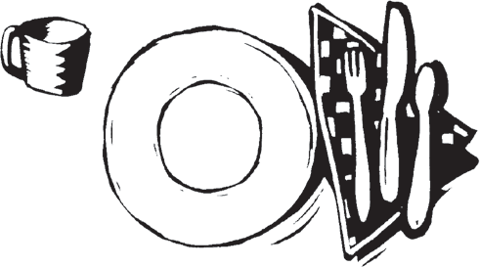
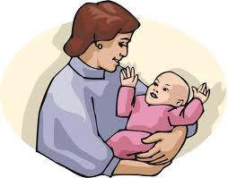
What jobs or chores do you have in your home? Draw a picture to show you how to help out in your house. Please turn to the back to draw your ideas.

4

Grades K-2 World War II - Science
Victory Gardens

During World War II some foods were scarce. Meat and sugar were hard to get. So were some fruits and vegetables. Feeding soldiers took much of America’s food.

Many people planted gardens in their yards. These were called victory gardens because the food grown at home helped America win the war. Home owners grew potatoes, carrots, onions and beets. They also grew tomatoes, green beans, cabbage, lettuce and peas.

Everyone in the family helped care for the garden. The soil was plowed. Seeds were planted. Weeds were pulled. And, when the vegetables were ready, the food was harvested.

Food that could not be eaten right away was preserved by canning in glass jars. Some foods, like potatoes, were stored in cool cellars.

People knew that vitamins in foods were important for good health. Their victory gardens grew healthy, nutritious food for folks at home.

What kind of vegetables would you grow if you grew a victory garden in your yard?

Key Words: Tell what you think is the meaning of each word.
Scarce
Plowed
Harvested
Preserved
Cellar
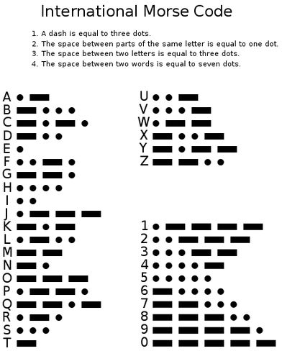

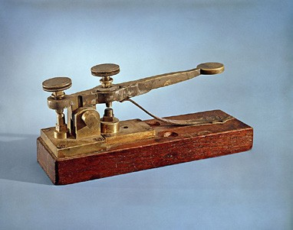
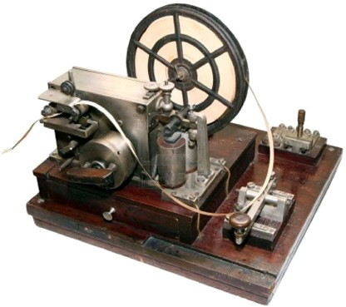

Grades 3-4 World War II – Language Arts

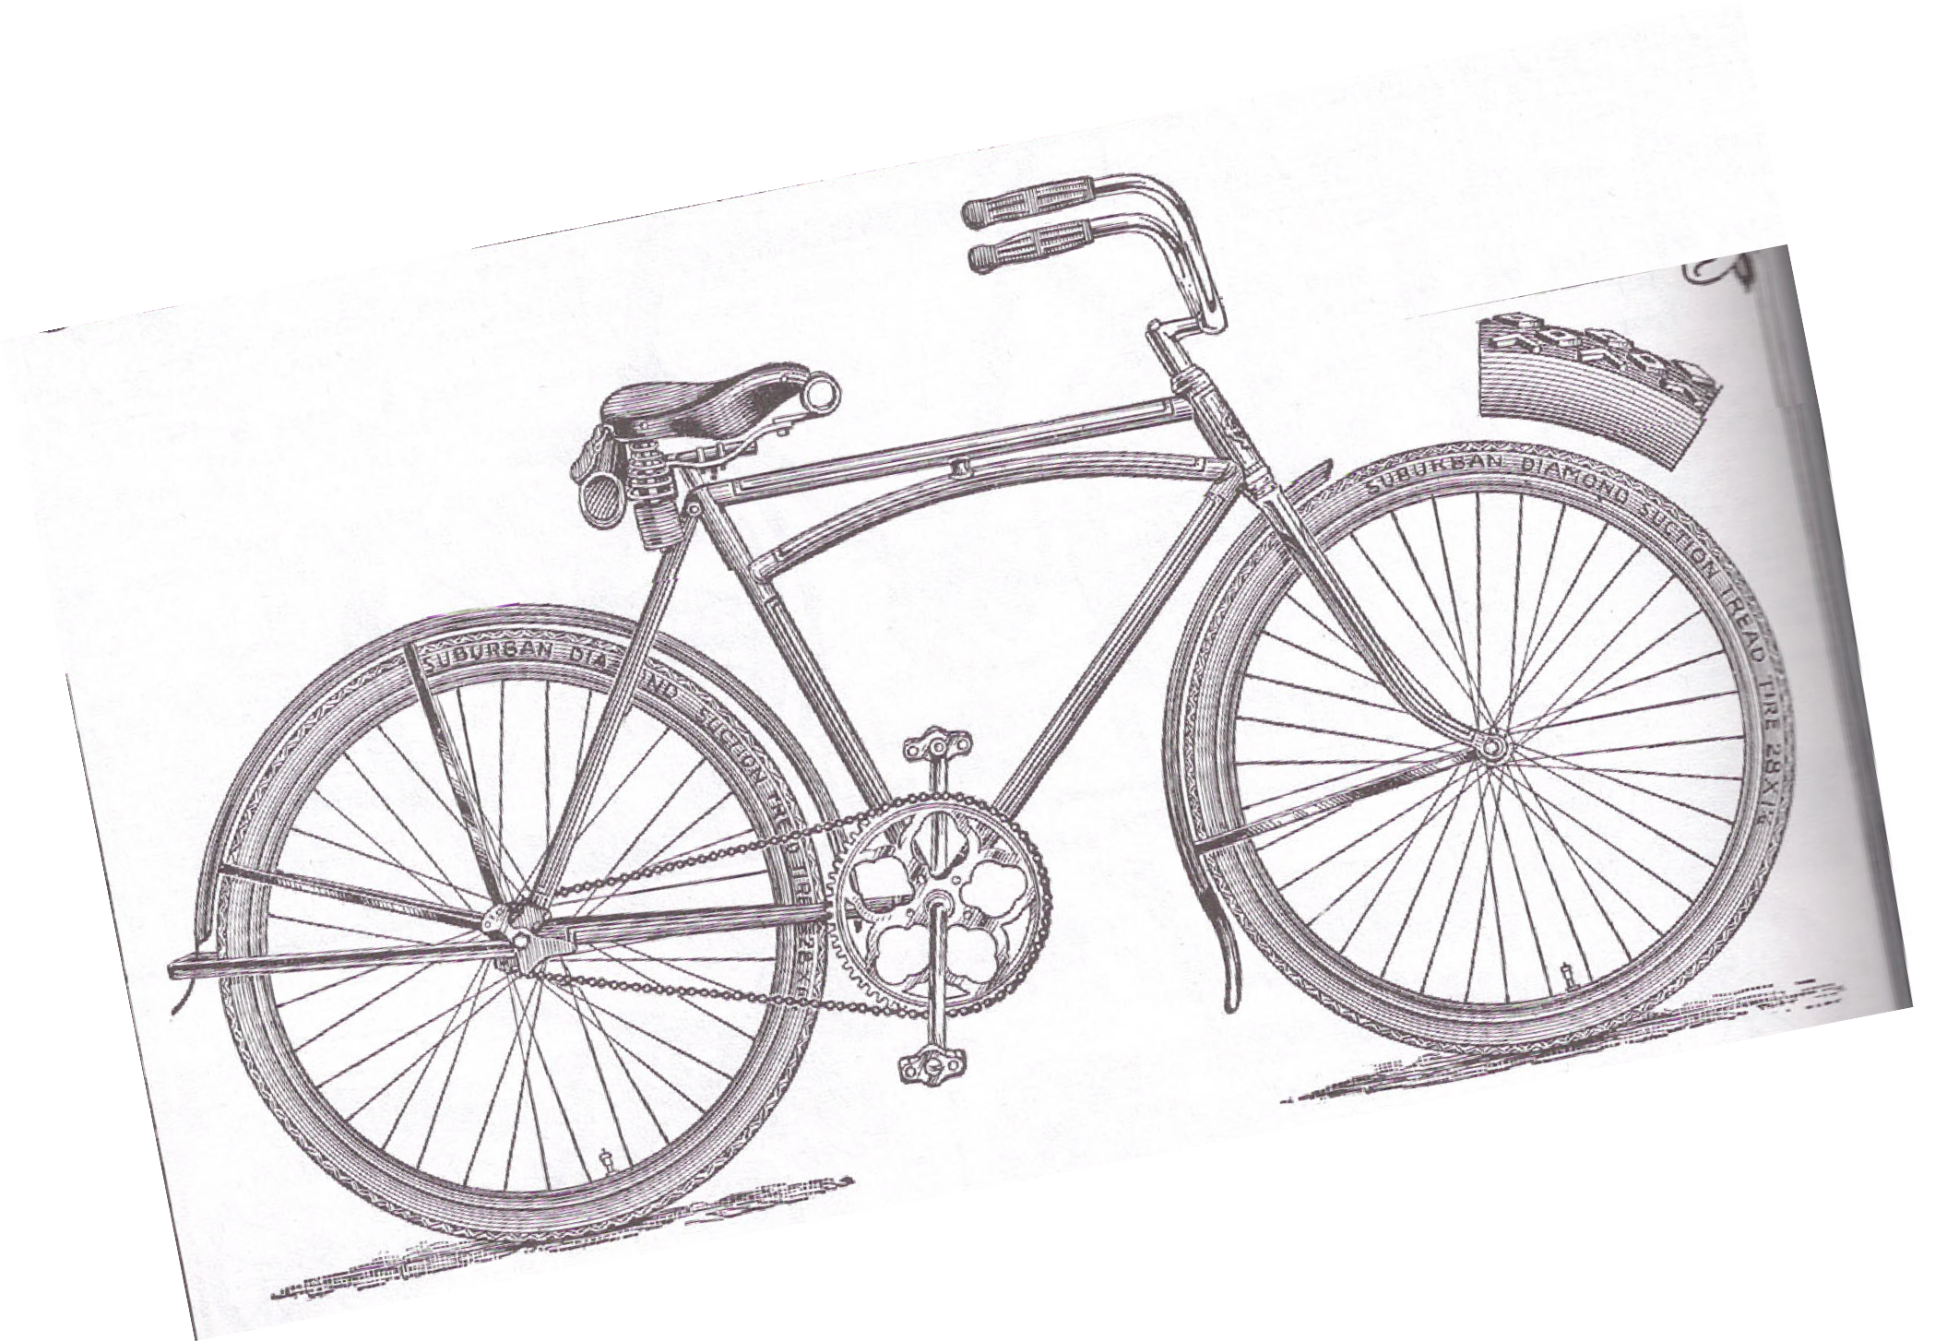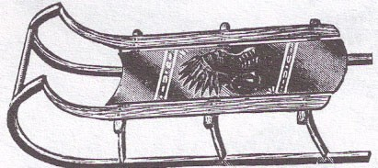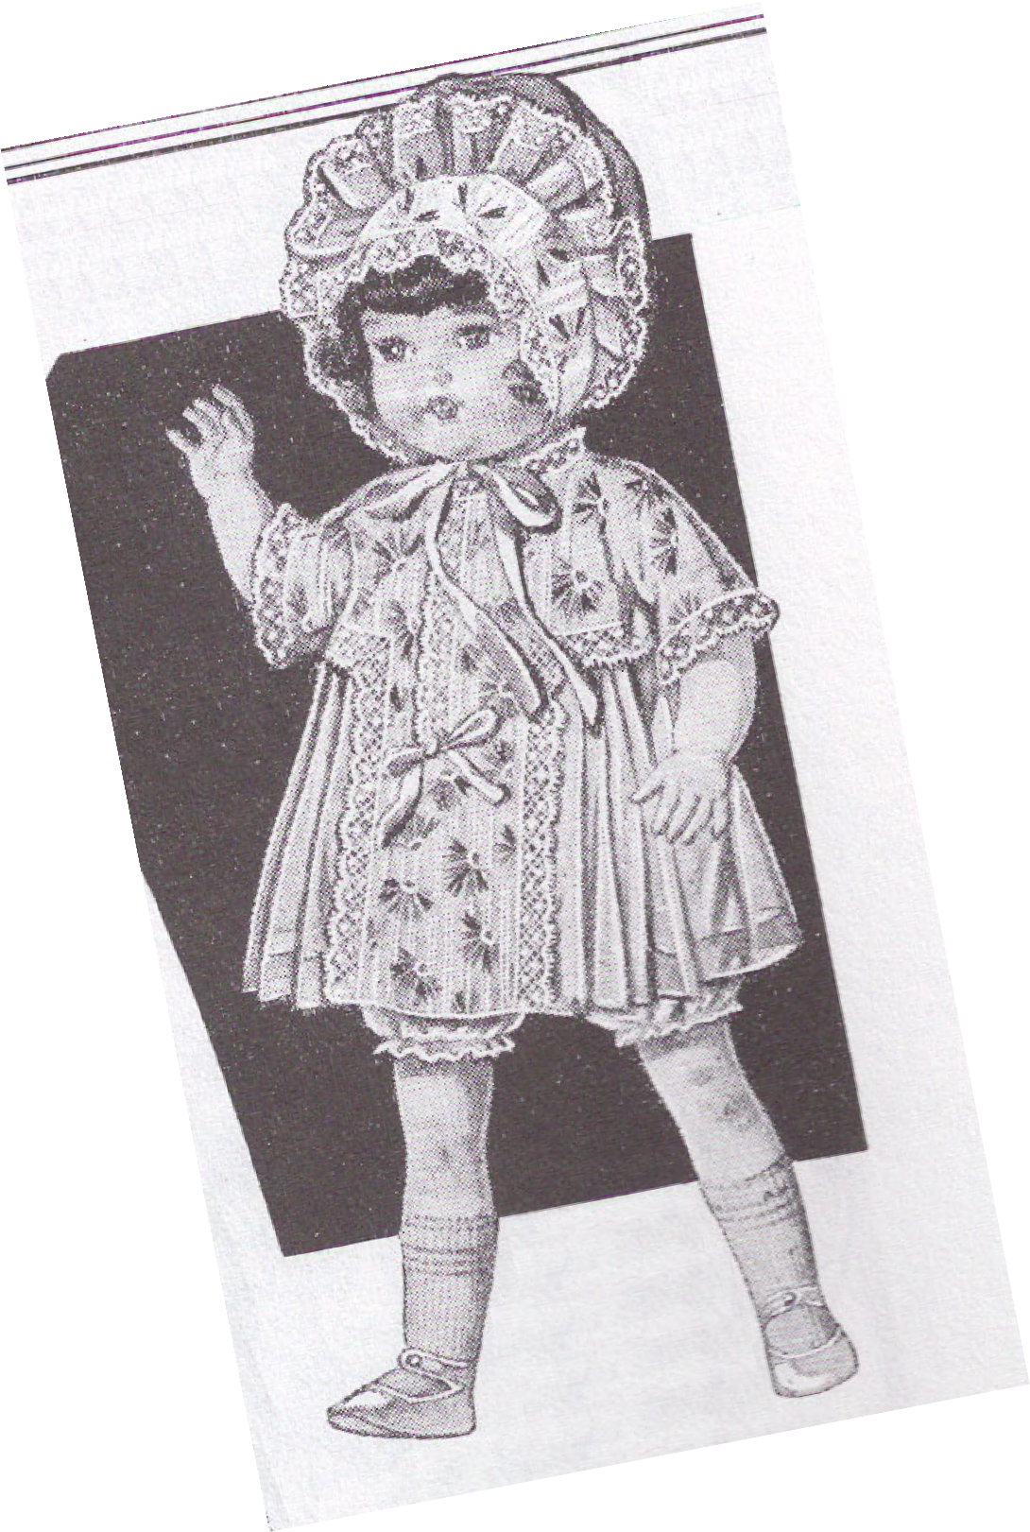Toys from WWII

Tell about your favorite toys today.

Grades 3-4 The Great Depression - Math

Rationing

Spring 1942
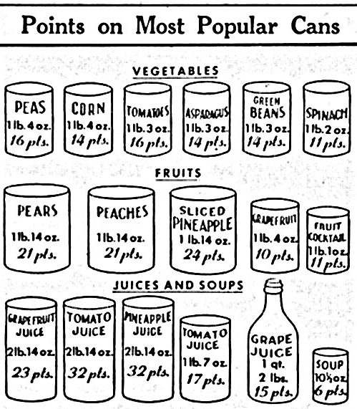
1. How many ration points would you spend if you bought a can of pears, a can of green beans, and a quart of grape juice? _______________. 2. Your ration allows you to spend 100 points this month. What items can you buy? _____________. 3. How many points did you spend? __________.
Grades 3-4 World War II – Social Studies

War Bonds
1944
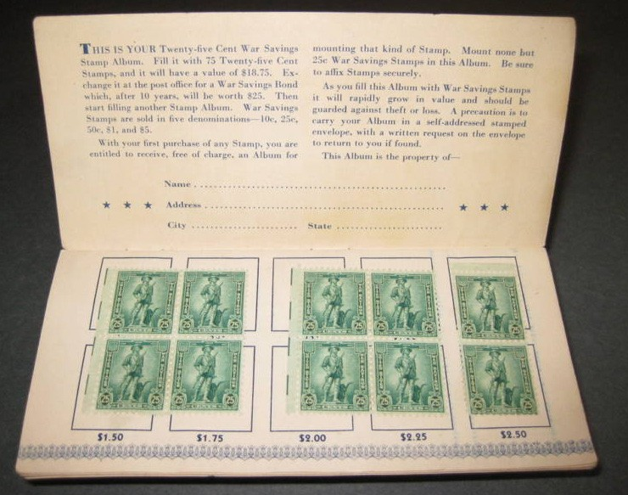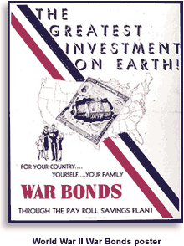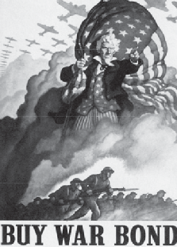

In 1944, the Uni ted States had been involved in the World War II since the bombing of Pearl Harbor in Hawaii by the Japanese on December 7th, 1941. Money was needed to build our military to fight battles in Europe and the Pacific.

To help raise money, the government issued U.S. War Bonds. Americans were still recovering from The Great Depression, so they had little money. Special stamps were issued that people could buy for as little as 10 cents. The stamps were saved until enough were collected in a booklet to buy a U.S. War Bond. Even school children were able to help their country by buying these stamps. Bonds were sold in denominations of $25 up to $10,000. The bonds cost 75% of their value. For example, a $25 bond would cost $18,75. If you kept the bond for 10 years, it would be worth $25.

- What event caused the United States to enter World War II?

- Where in the Pacific is Pearl Harbor located?

- Why were U.S. War Bonds sold?

- What could Americans, even school children do, to help them save money to buy a U.S. War Bond?

Grades 3-4 World War II - Science

Victory Gardens

There were shortages of many foods during World War II. Some such as meat and sugar were rationed, others like fruit and vegetables could be hard to find at times.
Many people planted Victory Gardens to provide vegetables for their families. Some were root vegetables such as potatoes, carrots, onions, turnips, beets, and radishes. These have leaves above the ground and the edible part of the plant growing underground. Some were vine plants that often use a support system such as poles of strings for the vines to climb. Tomatoes, green beans, cucumbers, and lima beans grow on vines. Many plants such as cabbage, lettuce, and peas grow close to the ground, or as corn, several feet above ground.
Victory Gardens required time and effort and the whole family helped – parents, grandparents, and children. Land had to be plowed, often with a hand plow, or for larger gardens, horse drawn plows. Then seeds were sown, weeds hoed or
pulled, insects sprayed or hand-picked from the plants, and finally harvested when ready. The fresh vegetables tasted wonderful! Those that could not be eaten right away were canned in glass jars for later use. Or those, like potatoes were stored in a cool area such as a cellar under the house. Some like sauerkraut which is made with cabbage were preserved in stoneware crocks.
Keeping healthy was especially important during the war because many of our country’s doctors and nurses were overseas caring for our troops who had been wounded. People knew that the vitamins and minerals in vegetables would help them be healthy. Since that time much more has been learned about additional nutrients found in foods.
John Glenn’s parents had vegetable gardens each summer, and John helped with them as a boy. But by the time they were called Victory Gardens, John was in the Marines and helping our country win the war.
- What vegetables would you plant in a garden?
- What vegetables do we eat now that were not well known in 1944?

Grades 5+ WorldWar II – Language Arts
Oral Histories 1941-1945: Veterans of WWII
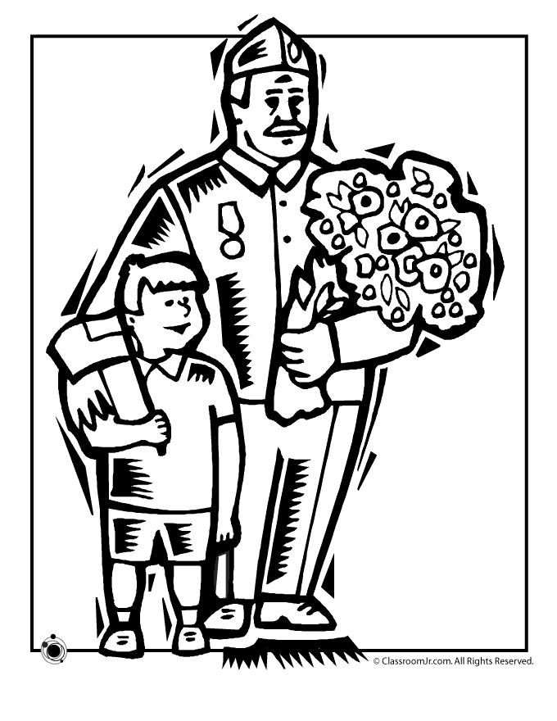
Doing Oral Histories is a good way for students to learn firsthand about World War II. Assign students to prepare an oral report based on an interview with a person who experienced WWII in the military. You may want to work with a retirement center to identify people to interview. Students may not have a grand- parent, neighbor, or friend that lived during WWII. Encourage students to take notes and/or record their interview. Tape recording the interview will be the most helpful to the student for reviewing the actual responses of the person interviewed. Below are some sample questions that may be asked:
- When/where did you enlist in the military?
- What is the difference between enlisting and being drafted?
- Where did you do your Basic Training?
- How old were you when you entered the military?
- What branch of the military did you serve in?
- What was basic training like?
- If you left the United States to travel to one of the battlefronts in the European Theater of Operation (ETO) or in the South Pacific, how many days did you travel to arrive at your destination?
- 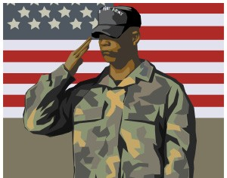If you fought in the front lines, what did you have to eat during combat?
- When did you write letters to mail back home to your family?
- How did you receive mail from your family?
- What was the most difficult military assignment that you were ordered to carry-out?
- When were you discharged from the military service? Work with students to develop more questions.

Grades 5+ World War II – Language Arts

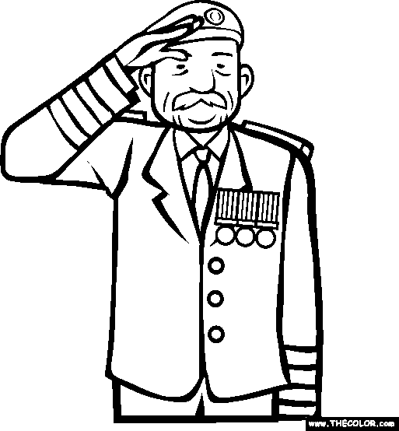
Oral Histories 1941- 1945: Home Front during WWII

Doing Oral Histories is a good way for students to learn firsthand about World War II. Assign students to prepare an oral report based on an interview with a person who experienced WWII on the home front. You may want to work with a retirement center to identify people to interview. Students may
not have a grandparent, neighbor, or friend that lived during WWII. Encourage students to take notes and/or record their interview. Tape recording the interview will be the most helpful to the student for reviewing the actual responses of the person interviewed. Below are some sample questions that may be asked:
  - Where did you live when the attack on Pearl Harbor took place on December 7th, 1941?
  - How did you feel when you learned the news about Pearl Harbor?
  - What did you think when our President, Franklin D. Roosevelt, declared war on Japan on December 8th, 1941?
  - What thoughts went through your mind when both Germany and Italy declared war on the United States on December 11th, 1941?
  - How did the war change your normal routine at home?
  - What challenges did the rationing of consumer goods; like sugar, meat, gasoline, tires, and shoes, among other products, present to you and your family.
  - What do you remember about using ration books to purchase your allotment of needed staples?
  - What members of your family, friends, and neighbors served in the military war efforts?
  - What patriotic activities helped the war effort you were in?
  - Where were you on May 7th, 1945, V- E Day when Germany surrendered unconditionally?
  - What do you remember about V – J Day August 15th, 1945? Encourage students to develop their own questions.

Grades 5+ World War II – Language Arts

Word Search
Have you ever wondered what life would be like during WWII? It was a very difficult time for the people living in the United States because they did not have some of the goods and service that were available before the war. It was a time when everyone in the United States learned to work together so that the troops fighting in the war in Europe and the Pacific could have all that they needed to stay strong and healthy. Please talk about the words from World War II and then have fun finding them in the word search below.

G W A W X J Q U L G X I S R M G A D T F A R D Y S U T Z E O N R N T R O O P S D O T E K R I B A M T R E D C R O S S N S L O G M I E X C M E X M Z U E C N A E G C G T G W Q Y S B C Y D P T E K R A M K C A L B O C S O J U O N O L S B U U Q D E P R T O O D U F F E L G I E R A P P I E T U R I U I I G A I C E P C Q O R S A L O L T I L R S O S O N A R O D M M L Z S E Y D G N I N O I T A R A A I N F L A T I O N L V Q R Q C R E T A D N A M F U R K R L N

Allies
Black Market Blitz
Bunker Camouflage Decoy Draft
Espionage Inflation Mandate Microfilm Morse Code Propaganda Radar
12
Rationing Recycling Red Cross Sonar
Storm Troopers Troops
USO
War Bonds

Grades 5+ The Great Depression - Math
Rationing
During World War II, people could not just walk into a store and buy as much as they wanted, even if they had the money to. You couldn’t buy as much sugar, butter, or even meat as you wanted. These items, along with many others, were rationed, which means that you were only allowed to buy a small amount of them. The government started rationing things because certain things were in short supply during the war, and rationing was the only way to make sure everyone got their fair share of things. Rationing also helped the soldiers overseas to keep a supply of food and weapons by not over-using the supplies at home.

Rationed Items:
Tires Cars Bicycles Gasoline
Fuel, Oil, & Kerosene Solid Fuels
Stoves
Rubber Footwear Shoes

Sugar Coffee
Processed Foods Meats, canned fish
Cheese, canned milk & fats
Typewriters

Rationing Duration:
January 1942 to December 1945
February 1942 to October 1945
July 1942 to September 1945
May 1942 to August 1945
October 1942 to August 1945
September 1943 to August 1945
December 1942 to August 1945
October 1942 to September 1945
February 1943 to October 1945
May 1942 to 1947
November 1942 to July 1943
March 1943 to August 1945
March 1943 to November 1945
March 1943 to November 1945
March 1942 to April 1944
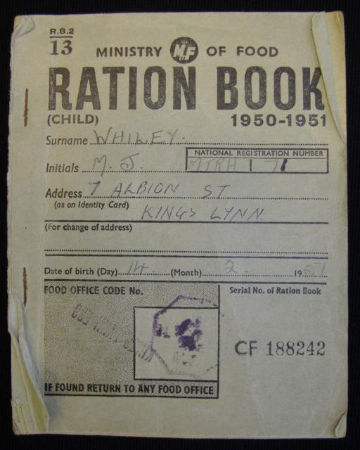
13

Grades 5+ World War II – Social Studies

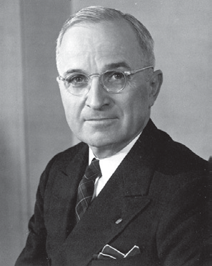Important People
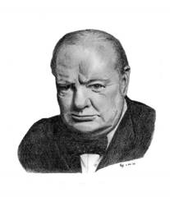ir Winston Churchill: As prime minister of Britain, Churchill was able to inspire the British eople to great patriotism. This gave them the courage to deal with the physical dangers and sacrifices demanded of them during the war.
S
p s

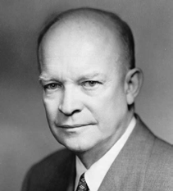Dwight D. Eisenhower: An army general, Eisenhower served as the supreme commander of the Allied Expeditionary Forces in Europe during World War II. He planned the invasion of France known as Operation Overlord, which helped the Allies to defeat Hitler. Eisenhower later served as America’s 34th president.
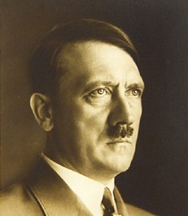
Adolf Hitler: The German dictator who started World War II to create a great German state for all Germans. He sought the destruction of all European Jews, millions of whom were killed in Nazi death camps. In 1945, Hitler committed suicide in his underground bunker in Berlin as Allied troops approached.
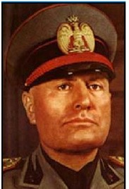
Benito Mussolini: A fascist, Mussolini ruled Italy from 1922 to 1943 through intimidation and total control of the media and military. During World War II he sided with Nazi Germany.

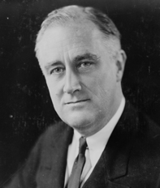Franklin D. Roosevelt: America’s 32nd president, Roosevelt was known as FDR. Before the United States entered the war on December 8th, 1941, Roosevelt helped Britain, the Soviet Union, France, and other countries fighting Germany by providing all kinds of supplies through his 1941 Lend-Lease Act. Roosevelt died before the end of the war in April 1945.
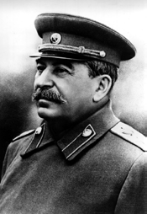
Joseph Stalin: The dictator of the Soviet Union from 1928 through World War II until he died in 1953, Stalin is credited with transforming the Soviet Union into a superpower. He was also responsible for the deaths of millions of his own people who were sent to harsh labor camps, mostly accused of being enemies of the state. After Hitler invaded the Soviet Union, Stalin sided with Britain, and the Soviet Union became one of the Allied powers.

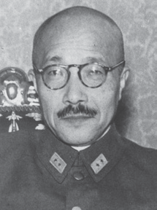General Hideki Tojo: Japan’s prime minister during most of the war (until July 1944), Tojo commanded the Japanese military and ordered the attack on Pearl Harbor on December 7th, 1941. After Japan surrendered to the Allied forces in 1945, Tojo shot himself before being arrested by the U.S. Military. He survived but was executed as war criminal in 1948.

Harry S. Truman: Truman became America’s 33rd president when President Roosevelt died. It was his decision to drop two atomic bombs on Japan, which quickly brought an end to World War II.

World War II Timeline

1939
Grades 5+ World War II – Social Studies

August: The Soviet Union and Germany sign a nonaggression pact, agreeing not to fight each other when they both invade Poland.

September: Hitler invades Poland from the west. France, Great Britain, Australia, New Zealand, Canada, South Africa, and India declare war on Germany. This is the official start to World War II. The countries against Germany are called the Allies. The Soviet Union invades Poland from the east.
October: Poland surrenders to Hitler. The Nazis begin persecuting Polish Jews.
November: The United States begins selling military supplies to Britain and France. Meanwhile, the Soviet Union attacked Finland.

1940
April: Germany invades Denmark and Norway, Denmark surrenders.
May: Germany invades Belgium, the Netherlands, Luxembourg, and France. Winston Churchill becomes Britain’s new prime minister. Belgium and the Netherlands surrender.
June: Italy enters the war on the side of Nazi Germany, declaring war on France and Britain.
France and Norway surrender.

July: Churchill rejects a peace pact proposed by Hitler. The Battle of Britain begins when Germany starts bombing Britain.

October: Germany intensely bombs London. This “blitz” continues for 57 nights, killing more than 40,000 citizens. The bombing of London continues off and on until the following May, but Britain fends off Germany’s attacks and Hitler is unable to invade. Japan joins Italy and Germany in fighting the Allies. This is known as the Tripartite Pact, and the three countries are called the Axis Powers.

1941
March: The United States continues to send military equipment and other supplies to the Allies but no longer requires payment, at least not until after the war.

June: Germany invades the Soviet Union, violating the nonaggression pact Germany signed with the Soviet Union in 1939. The invasion was called Operation Barbarossa.
July: The Soviet Union joins the Allies.
December: Japan attacks Pearl Harbor, an American naval base in Hawaii, along with other Allied bases in the Pacific and Asia. The United States and Britain declare war on Japan. Germany and Italy declare war on the United States.

Grades 5+ World War II – Social Studies

1942
January/February: The Nazis organize their “final solution,” the complete extermination of European
Jews in death camps. Japanese troops take control of large portions of East Asia and the Pacific, including Hong Kong, Singapore, the Philippines, Thailand, Malaysia, and Burma.

February: President Roosevelt signs Executive Order 9066, allowing the internment of Japanese Americans, as well as German and Italian Americans and other foreigners.
June: The United States wins the Battle of Midway, a major turning point in the war in the Pacific.
December: Scientists in the United States work on an atomic bomb.

1943

Allies.

July: Mussolini is removed from power by the Italian king. Italy begins secret peace talks with the

October: Italy surrenders to the Allies and then declares war on Germany.
November: Churchill, Roosevelt, and Stalin meet in Teheran, Iran, to discuss Operation Overlord, the

Allied invasion of Normandy, France, against Germany’s army.

1944
January: General Dwight D. Eisenhower takes charge of planning Operation Overlord.
June: Allied forces launch Operation Overlord. They land at Normandy on June 6, known as D- day. In heavy fighting the Allies gradually push the Germans back towards Germany. Over the following months, city after city in Europe is liberated by the Allies as the Germans retreat.
July: The entire Japanese government resigns.
August: Paris is liberated by Allied troops.
November: Roosevelt is elected to his fourth term as U.S. President. He was the only president to serve more than two terms.

1945
January: Auschwitz, a Nazi death camp in Poland, is liberated. The Americans defeat the Germans in the Battle of the Bulge.

February: The United States takes the Pacific island of Iwo Jima in a bloody battle memorialized in a famous photo of six marines raising the American flag. Churchill, Roosevelt, and Stalin meet in Yalta to discuss the end of the war and how to divide up Germany.

April: Roosevelt dies. Vice President Harry S. Truman is sworn in as president. Mussolini is captured by Italian partisans. Hitler commits suicide in his Berlin bunker.
May: Germany surrenders on May 7. Truman declares May 8 V-E Day (Victory in Europe).

Recycling
Grades 5+ World War II - Science
Recycling
Mock Apple Pie

After the bombing of Pearl Harbor, the United States Government asked Americans to collect and donate materials that could be used to help the war effort.
Newspapers were used in shell containers, blasting keys, bomb rings, and parachute flares. Aluminum was recycled for many products, but aluminum pots and pans were not suitable for aircraft production.
Cooking fat was saved and turned into collection sites. Glycerin is an important part of fat that can be used in making gunpowder and other explosives.
Other recyclables collected were tin, silk stockings, iron, steel, and metal toys. Used tires were also important because areas where raw rubber was grown had been captured by the Japanese.
Many schools sponsored scrap drives so that children could participate in collections. Some newspapers sponsored drives to collect recyclables and offered prizes for the largest amounts turned in.
What did you recycle today? Where is it collected?
Conserving
One of the most popular slogans of the war was, “Food is a Weapon”. Mothers were told to feed their families well for the sake of nutrition but to use only the amount of food that is necessary. Feeding an army takes a lot of food, so meatless days were encouraged, and recipes were published that used substitutes for foods that were in short supply. A new food that emerged during World War II was oleo margarine. Today we just call this butter substitute “margarine”. During the war margarine was bought as a solid white block of vegetable oils.
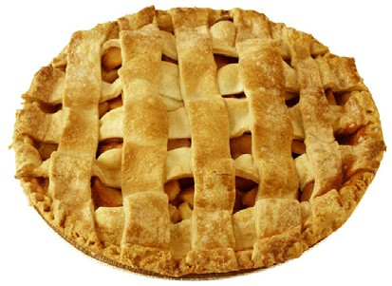
Makers of margarine knew that people would not like to see a white butter substitute on their bread. They added a packet of orange coloring to be mixed with the white material to make a yellow spread. At home, John Glenn asked for the job of mixing the margarine and coloring. He thought it looked like an interesting thing to do. But when he began to squeeze the two things together, he discovered it was very difficult. The block of vegetable oil was hard and tough to squeeze. The job turned out not to be fun at all.
Activity: See if you can find a recipe for Mock Apple Pie, a dessert made with crackers instead of apples. The Recipe can be found in the answer key.
with Ritz Cracker

Recycling
Grades 5+ World WarII - Science
Recycling
Compost Pile

We are familiar with the slogan, “Reduce, Reuse, Recycle.” Most of use try to practice it as best we can. Many of us believe that idea is new. The slogan is new, but the idea is an old one.
During the 1930’s depression, people lived by that slogan. Because jobs and money were scarce nothing in a household went to waste.
Today’s food cans are made of steel but during the depression those containers were made of tin. When the cans had been emptied, they were returned to a collection point to be recycled. This practice became vitally important during World War II because the country that was America’s only source of tin was captured during the first week of the war.
Many people in New Concord, Ohio were farmers or kept work animals during the 1930’s. Those animals had to be fed. Their feed was purchased in colorful, sturdy cloth bags that could be opened flat, washed, and sewn into dresses, shirts, pants, and other articles of clothing. No one ever just threw away a feed sack.
What about garbage? While some food scraps went to feed animals such as pigs, most of it was composted. Nearly every home had a compost pile. Uncooked vegetable matter, eggshells, and coffee grounds were deposited in a pile and covered with a layer of soil. Every time a deposit was made to the pile, that material was turned with a shovel. Soon the garbage became a layer of rich, nutritious soil that could be used to grow a victory garden.
Activity: make a compost box. Start with a banana peel, some potato shavings or any raw fruit or vegetable bits. Place the vegetable matter in a large jar (1 gal) with a cup of soil and 2 tablespoons of water. Make sure the lid is tight and shake well. Add a little more vegetable matter as time passes and keep shaking. It will take time, but you can watch new soil being made. Earthworms churn the soil and digest the vegetables make the new soil richer. Once you have a nice thick layer of dirt, you might bring in one or two worms to speed your soil making along.

Answer Key
ANSWER KEY FOR WWII
Language Arts Blue Star Flag : Color the flag as in the picture. You may look online also.
Math : 1. You spend $.81. You receive $.19.
    - You receive $7.25 in interest. A page would cost $.80. Four pages for $3.20
    - Dad will pay $.50 to see the movie. He will get $4.50 change. Popcorn will be $.20.
Chores : Answers will vary
Morse Code : The answer is: YOU ARE SPECIAL
Toys: Answers will vary.

Rationing:
- 50 ration points
- Answers will vary
- answers will vary

War Bonds:
The bombing of Pearl Harbor on December 7th, 1945 In Hawaii to help raise money for the war effort
Children could buy stamps for $.10 to fill a book and buy a bond.

Victory Gardens:
Some vegetables included peas, carrots, beans, beets, corn, zucchini, tomatoes, potatoes, lettuce, spinach.
Some vegetables eaten today and not then include: Avocados, Bok Choy, Arugula.
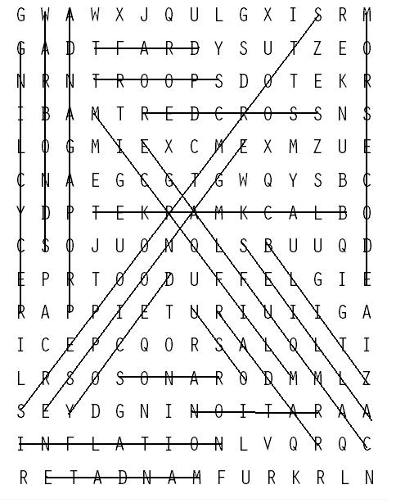Oral Histories : Answers will vary.
19
Word Search : See Answer Page

Answer Key

Rationing : Informational for further study Important people : Informational for further study Timeline : Informational for further study Recycling : Mock Apple Pie Recipe
Pastry for 2-crust 9-inch pie
36 RITZ Crackers, coarsely broken (about 1-3/4 cups crumbs) 2 cups sugar
2 tsp. cream of tartar Grated peel of 1 lemon 2 Tbsp. lemon juice
2 Tbsp. butter or margarine 1/2 tsp. ground cinnamon

PREHEAT oven to 425°F. Roll out half of the pastry and place in 9-inch pie plate. Place cracker crumbs in crust; set aside.
MIX sugar and cream of tartar in medium saucepan. Gradually stir in 1-3/4 cups water until well blended. Bring to boil on high heat. Reduce heat to low; simmer 15 minutes. Add lemon peel and juice; cool. Pour syrup over cracker crumbs. Dot with butter; sprinkle with cinnamon.
Roll out remaining pastry; place over pie. Trim; seal and flute edges. Slit top crust to allow steam to escape.
BAKE 30 to 35 minutes or until crust is crisp and golden. Cool completely.
Recycling today: Answers will vary
Composting: Possible classroom project.

20

